**Backorder Inquiry:** The Backorder Inquiry allows CNH dealers to look up their backorders based on order details, and cancel the backorders if they so choose.

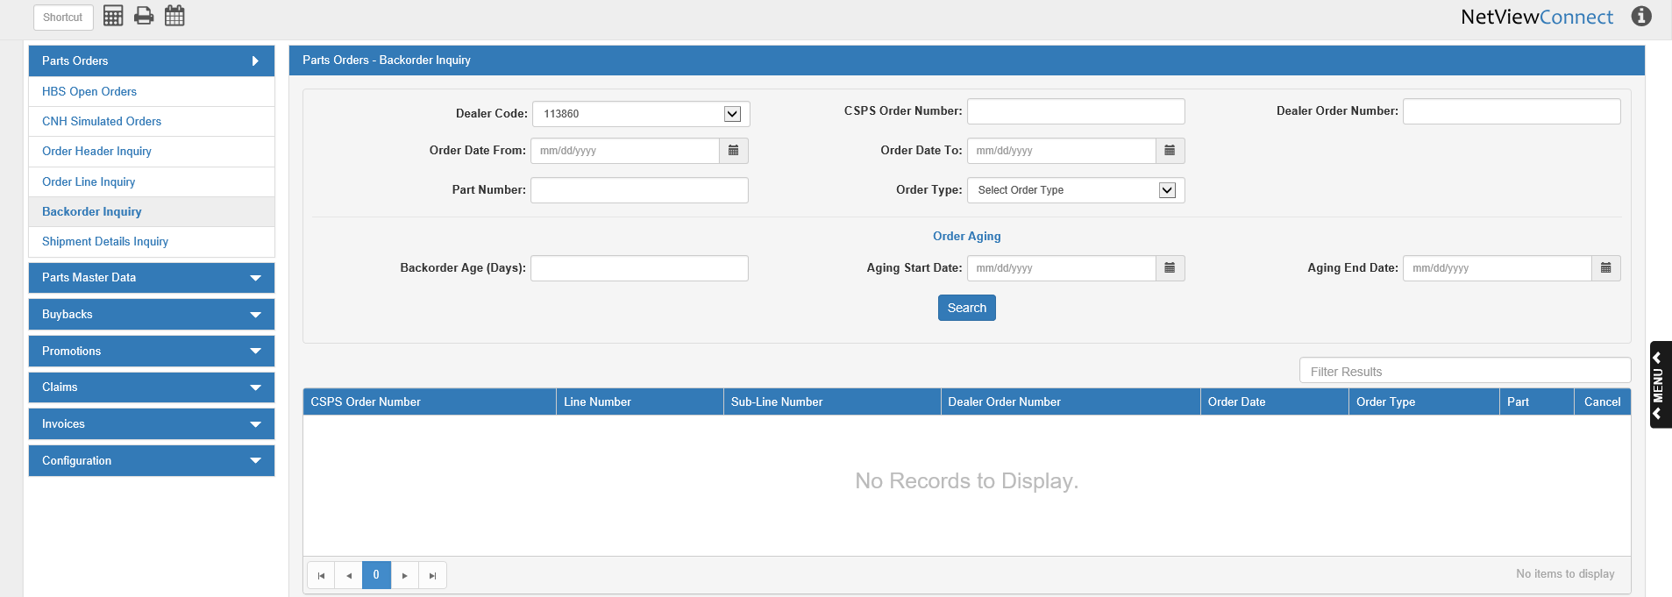

**Search Filter Fields:**

Dealer Code:Set the dealer code to search for. This applies mainly to CNH dealers that have more than one CNH code, and may have attached different codes to different orders.

CSPS Order Number: To search by the CNH-assigned order number, enter the number here.

Dealer Order Number: To search by the dealer-assigned order number, enter the number here.

Order Date From: To search by a range of order dates, enter the starting and ending order dates in these fields or select them from a calendar. To search by a single order date, enter the date in both fields.

Part Number: To search by the order’s part number, enter the number here.

Order Type: To search for the order type, select a type from the drop-down menu. **NOTE:** This feature will not work if you have not loaded the order types from CNH (see **Order Types** for more information).

Order Aging:

**Backorder Age (Days):** To search for a backorder by its age in days, enter the number of days in this field.

**Aging Start Date:** To search for a range of backorders by their aging, enter the starting date of an aging range (or a specific date) in this field or select it from the calendar.

**Aging End Date:** To search for a range of backorders by their aging, enter the ending date of an aging range (or a specific date) in this field or select it from the calendar.

**Search:** Click this button to start your search. The results grid will populate with backorders that match the search criteria. You can sort the results using the column headers (except for **Cancel**), or filter them by entering specific information in the **Filter Results** field.

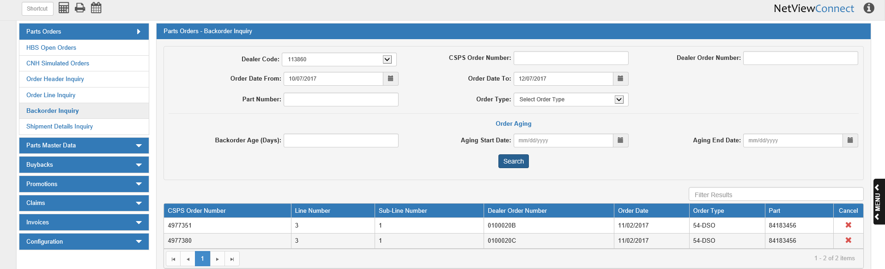

**Grid Columns:**

CSPS Order Number: This column shows the CNH-assigned order number for the backorder.

Line Number: This column shows the order line number for the backorder.

Sub-Line Number: This column shows the order sub-line number for the backorder.

Dealer Order Number: This column shows the dealer-assigned order number for the backorder.

Order Date: This column shows the order date for the backorder.

Order Type: This column shows the order type for the backorder.

Part: This column shows the part number for the backorder.

Cancel: Click the “X” in this column to cancel the backorder. The following message will appear:

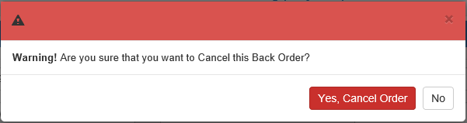

* Click **Yes, Cancel Order** to cancel the backorder.
* Click **No** to keep the backorder.